**HR DATA ANALYSIS PROJECT**

### **Project Overview:**

Analysing employees Data For A HR At Telecom Client To Gain Insights And Enhance Decision-Making.

### 

### **Project Objective:**

Generate A Improved Dynamic Dashboard’s For HR At Telecom Client To Analyze And Visualize Employees Data.

### **Project Requirements:**

* Problem Statement
* Data Source
* Software’s Required

**Problem Statements:**

1. Define relevant KPIs in hiring, promotion, performance and turnover, and create a visualisation
2. Write what you think some root causes of their slow progress might be

**Data Source:**

Utilizing Customers Data Collected By HR’s At telecom Client For Comprehensive Data Analysis.

Data Collection Tool : MS excel

**Software’s Used:**

OS Tool : ChatGPT

BI Tool : Microsoft Power BI

### **Project Process:**

**Step By Step Process:**

1. Collecting the Data set
2. Importing Data set Into Power Bi
3. Data Transform And Cleaning
4. Data Processing(DAX)
5. Data Visualization
6. Final Dash Board

**1.Collecting Data**

The Data set collected From HR’s At Telecom Client In The Form Of Excel Sheets.

**2.Importing Data set Into Microsoft Power BI**

* For That, Open Power BI, Go to Get Data and Select Excel Workbook Then, Make a Connection With Excel File
* After Completion of Connection we can Load Or Transform Data Based On Requirement

**3,4.Data Cleaning &Processing**

* After Loading Data Into PowerBI By Using The Power Query Editor, We Perform DAX(Data Analysis Express) For Data cleaning and Processing
* These Are Some Of DAX Formulas written for Data Visualization

**DAX Formula’s:**

**1.Employees Data table**

1. Total Employee's = COUNT('Pharma Group AG'[Employee ID])
2. Voluntary_Turnover_Rate =DIVIDE(CALCULATE(COUNTROWS('Pharma Group AG'), 'Pharma Group AG'[FY20 leaver?] = "Yes" && 'Pharma Group AG'[In base group for turnover FY20] = "N"), COUNTROWS('Pharma Group AG'))
3. Overall_Turnover_Rate =DIVIDE(CALCULATE(COUNTROWS('Pharma Group AG'), 'Pharma Group AG'[FY20 leaver?] = "Yes")COUNTROWS('Pharma Group AG'))
4. Male Count = CALCULATE(COUNTROWS(FILTER('Pharma Group AG','Pharma Group AG'[Gender]="Male")))
5. Male % = DIVIDE([Male Count],[Total Employee's])
6. Involuntary_Turnover_Rate =DIVIDE(CALCULATE(COUNTROWS('Pharma Group AG'), 'Pharma Group AG'[FY20 leaver?] = "Y" && 'Pharma Group AG'[In base group for turnover FY20] = "Yes"),COUNTROWS('Pharma Group AG'))
7. FY21 Promotion Count = CALCULATE(COUNTROWS(FILTER('Pharma Group AG','Pharma Group AG'[Promotion in FY21?]="Yes")))
8. FY20 Promotion Count = CALCULATE(COUNTROWS(FILTER('Pharma Group AG','Pharma Group AG'[Promotion in FY20?]="Y")))
9. FY20 Leaver Count = CALCULATE(COUNTROWS(FILTER('Pharma Group AG','Pharma Group AG'[FY20 leaver?]="Yes")))
10. FeMale Count = CALCULATE(COUNTROWS(FILTER('Pharma Group AG','Pharma Group AG'[Gender]="Female")))
11. Female % = DIVIDE([FeMale Count],[Total Employee's])
12. Average Male Performance Rating =CALCULATEAVERAGE('Pharma Group AG'[FY20 Performance Rating]),'Pharma Group AG'[Gender] = "Male")
13. Average Female Performance Rating CALCULATE(AVERAGE('Pharma Group AG'[FY20 Performance Rating]),'Pharma Group AG'[Gender] = "Female")
14. % FY21 Promoted = DIVIDE([FY21 Promotion Count],[Total Employee's])
15. % FY21 Male Promoted =
16. VAR TotalFemaleEmployees =CALCULATE(COUNTROWS('Pharma Group AG'),'Pharma Group AG'[Gender] = "Male" )

VAR FemalePromoted =CALCULATE( COUNTROWS('Pharma Group AG'),'Pharma Group AG'[Gender] = "Male",'Pharma Group AG'[Promotion in FY21?] = "Yes") RETURN DIVIDE(FemalePromoted, TotalFemaleEmployees)

1. % FY21 Female Promoted VAR TotalFemaleEmployees CALCULATECOUNTROWS('Pharma Group AG'),'Pharma Group AG'[Gender] = "Female")VAR FemalePromoted =CALCULATE COUNTROWS('Pharma Group AG'),'Pharma Group AG'[Gender] = "Female" 'Pharma Group AG'[Promotion in FY21?] = "Yes")

RETURN DIVIDE(FemalePromoted, TotalFemaleEmployees)

1. % FY20 Promoted = DIVIDE([FY20 Promotion Count],[Total Employee's])
2. % FY20 Male Promoted =VAR TotalFemaleEmployees CALCULATECOUNTROWS('Pharma Group AG'),'Pharma Group AG'[Gender] = "Male)

VAR FemalePromoted CALCULATE(COUNTROWS('Pharma Group AG')'Pharma Group AG'[Gender] = "Male",'Pharma Group AG'[Promotion in FY20?] = "Yes)

RETURN DIVIDE(FemalePromoted, TotalFemaleEmployees)

1. % FY20 Male Hires =VAR TotalFemaleEmployees = CALCULATE( COUNTROWS('Pharma Group AG'),'Pharma Group AG'[Gender] = "Male")

VAR FemalePromoted =CALCULATE( COUNTROWS('Pharma Group AG'), 'Pharma Group AG'[Gender] = "Male",'Pharma Group AG'[New hire FY20?] = "Y" )

RETURN DIVIDE(FemalePromoted, TotalFemaleEmployees)

1. % FY20 Female Promoted = VAR TotalFemaleEmployees = CALCULATE(COUNTROWS('Pharma Group AG'),'Pharma Group AG'[Gender] = "Female" )

VAR FemalePromoted = CALCULATE( COUNTROWS('Pharma Group AG'),'Pharma Group AG'[Gender] = "Female", 'Pharma Group AG'[Promotion in FY20?] = "Yes" )

RETUR DIVIDE(FemalePromoted, TotalFemaleEmployees)

1. % FY20 Female Hires = VAR TotalFemaleEmployees = CALCULATE(  COUNTROWS('Pharma Group AG'), 'Pharma Group AG'[Gender] = "Female" )

VAR FemalePromoted = CALCULATE COUNTROWS('Pharma Group AG'), 'Pharma Group AG'[Gender] = "Female", 'Pharma Group AG'[New hire FY20?] = "Y")

RETURN DIVIDE(FemalePromoted, TotalFemaleEmployees)

**5.Data Visualization**

* After Cleaning And Processing The Data According To The Requirements of Human Resource At Telecom, Prepare Dashboards’ For A HR At Telecom To Get Insights And Improve Decision-Making

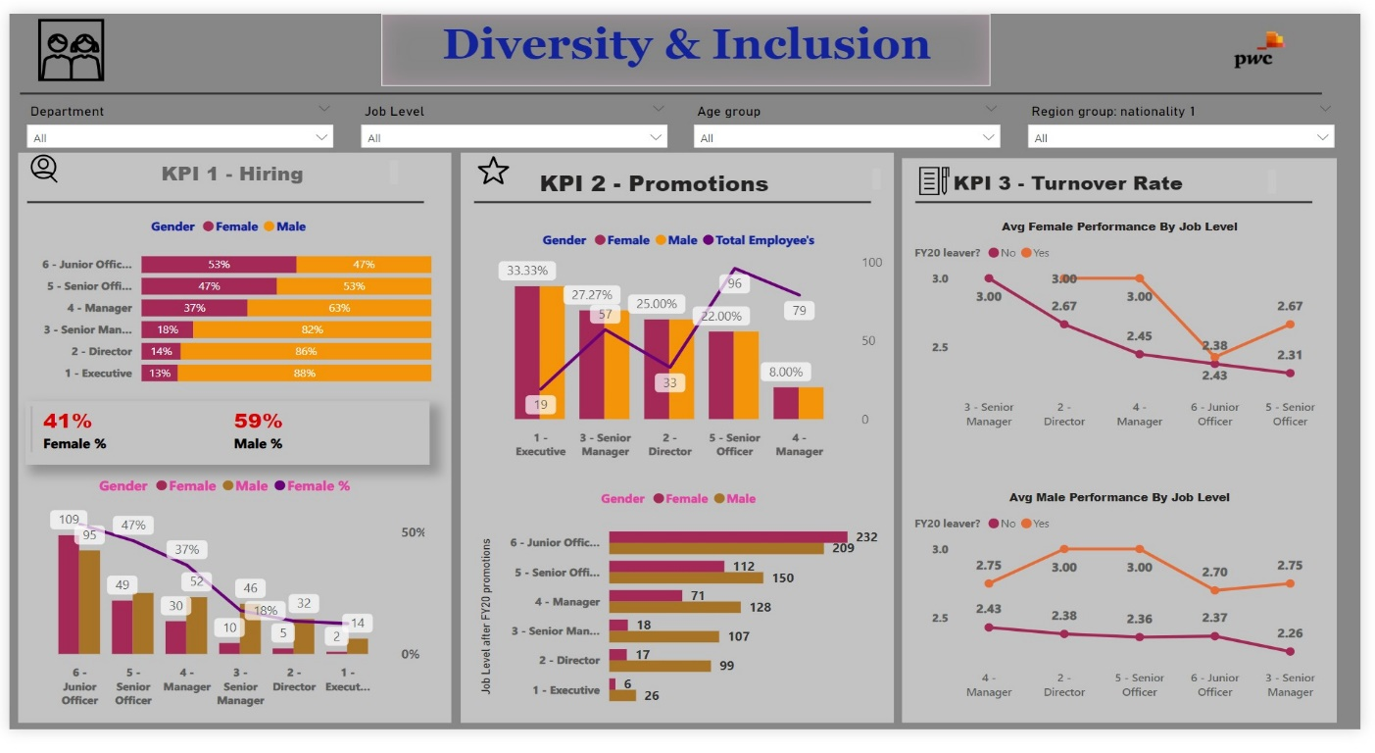

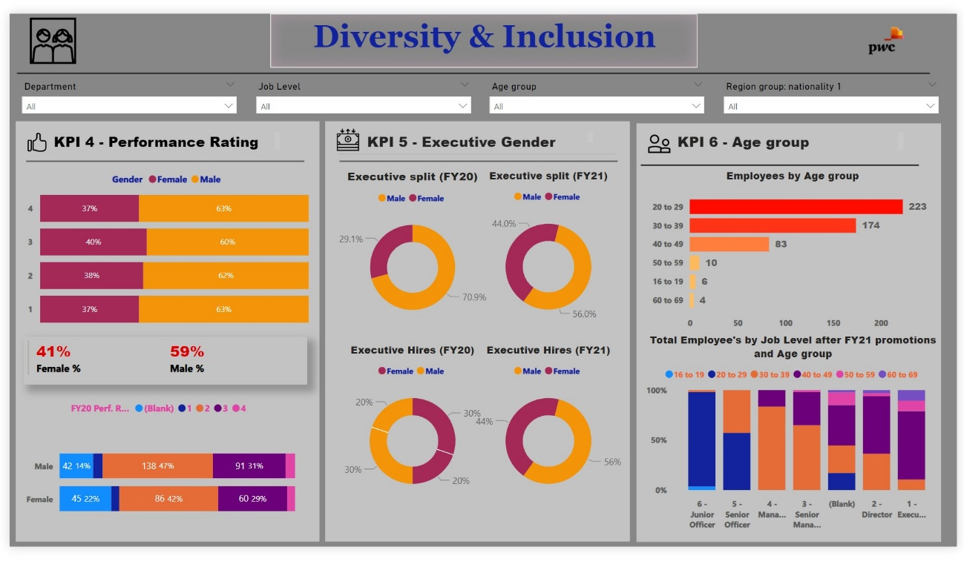

### **Conclusion:**

**For KPI’s**

**Gender Representation:**

* There is a noticeable disparity in gender representation, especially at different job levels, with a higher percentage of females hired at junior levels but males dominating senior management positions.

**Promotion Rates:**

* Females have a higher promotion rate at junior levels, but this trend reverses at senior positions, indicating potential barriers to advancement for females in higher roles.

**Turnover Rate:**

* The turnover rate for females is higher across all job levels except for senior management, suggesting possible issues with job satisfaction or work environment that need to be addressed.

**Performance Rating:**

* There appears to be a gender imbalance in performance ratings and executive positions, with males having a higher representation.

**Age Distribution:**

* The majority of employees fall within the 30-39 age group, which could have implications for succession planning and diversity efforts.

**Diversity Measures:**

* The data suggests that there may be opportunities to enhance diversity and inclusion, particularly by focusing on improving gender balance in leadership roles and addressing any disparities in performance ratings.

**Root causes of their slow progress**

**Gender Imbalance in Hiring:**

* A skewed gender ratio at the hiring stage can perpetuate a lack of diversity at higher levels.

**Promotion Disparities:**

* Unequal promotion rates between genders suggest systemic barriers that prevent equal advancement opportunities.

**Higher Turnover Rate for Females:**

* A higher turnover rate among females, especially in senior roles, may indicate issues with the work environment or culture that are not conducive to retention.

**Performance Rating Disparity:**

* If males are consistently receiving higher performance ratings, it could indicate a bias in evaluation processes or a lack of support for female employees’ development.

**Executive Gender Imbalance:**

* A low percentage of female executives suggests barriers to women reaching top leadership positions, which could be due to unconscious bias, lack of mentorship, or insufficient career development opportunities for women.

**Age Group Concentration:**

* A workforce concentrated in specific age groups may lack the benefits of intergenerational diversity, such as varied perspectives and experiences, which can hinder innovation and progress.